Marks Claimed

* An outdoor section built using the Terrain editor (including textures, trees, hills and crevices, appropriate textures, etc.) (25%)
* An indoor section built using Unity primitives (cubes, spheres, etc) and/or ProBuilder (25%)
* A First-person controller with which the player can navigate the scene.
* Appropriate textures on the indoor section (5%)
  + With normal maps (5%)
* A simple single-state animation (5%)
* NavMesh Agents (5%)
  + Multiple, different types of NavMesh Agents (5%)
* Reflection-probes and reflective surfaces (5%)
* Particle Systems(10%)
* Use of multiple cameras (e.g. overlaid cameras or rendering to a texture) (10%)
* Emissive materials (5%)

**Total Marks claimed: 105%**

**Challenges/changes**

**My Maze**

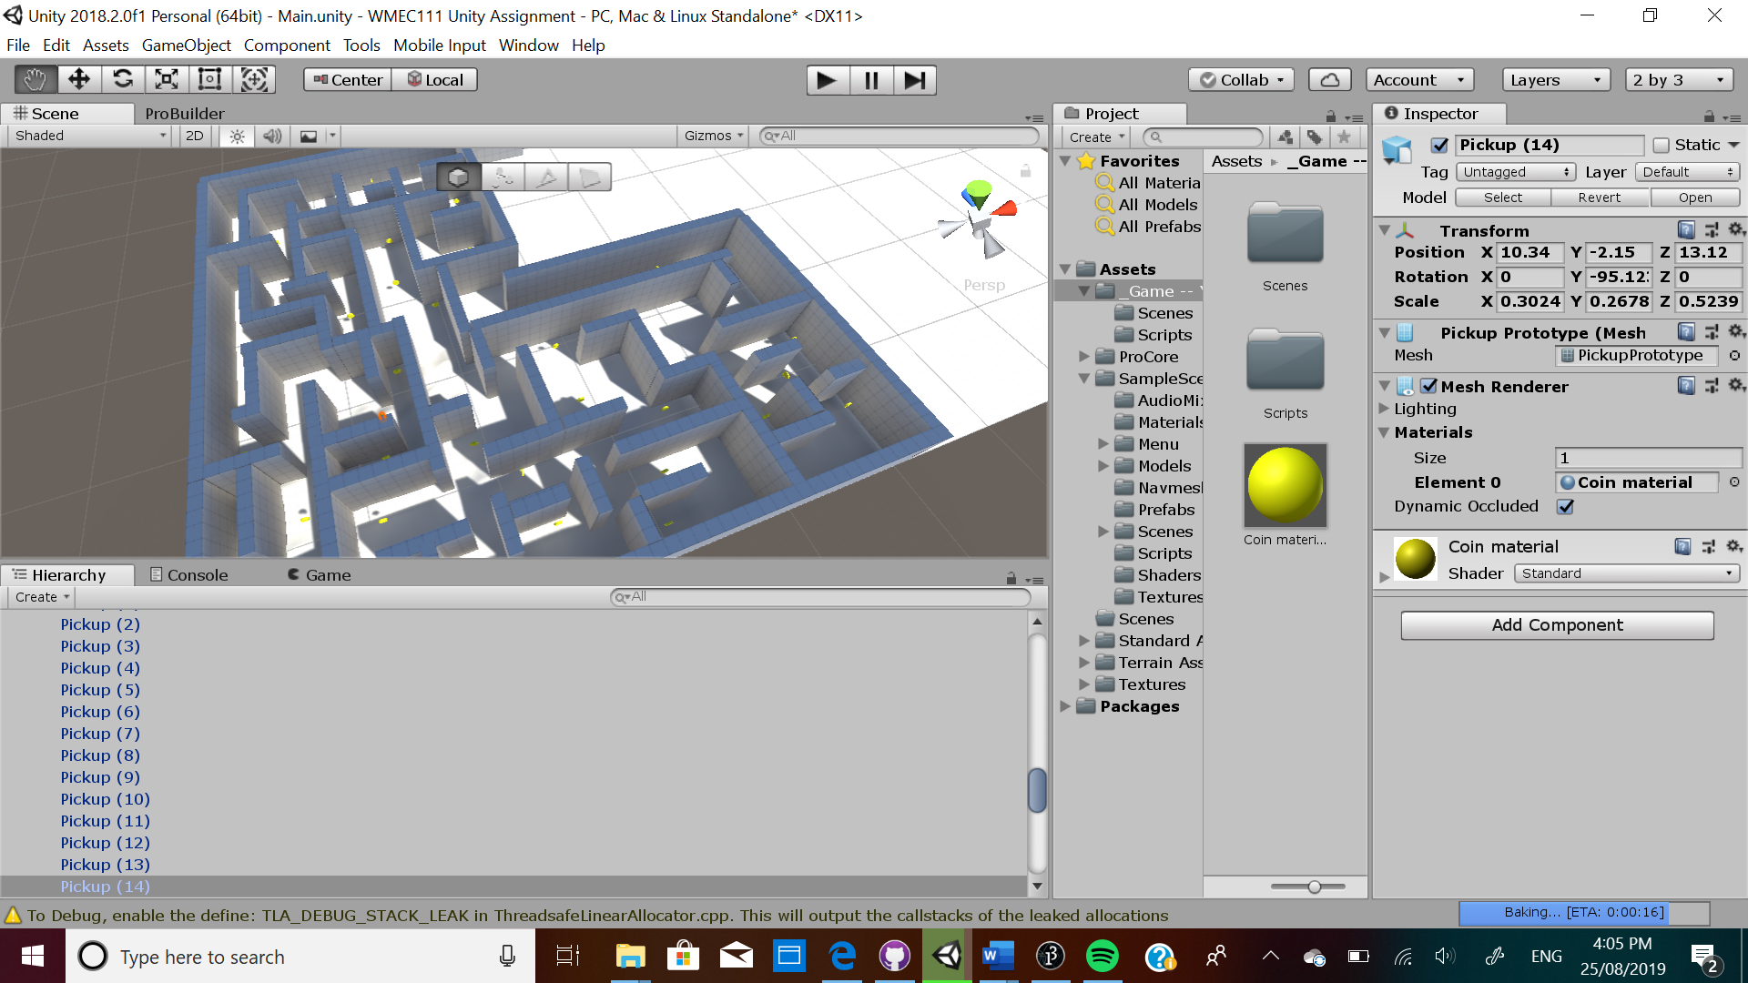

Snapping the cubes together were hard as I had to continually rotate the view of my maze to see if the cubes were aligned together. I had to remove the coins in my games as I didn’t know how to make the FPS controller to receive it during the game and I couldn’t keep score of it.

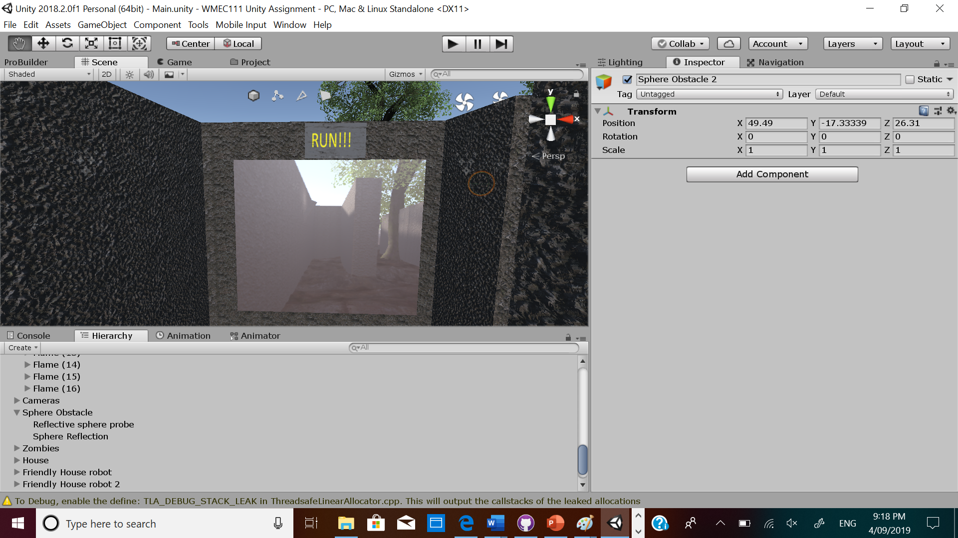

Since I didn’t add coins I needed to add a sub goal element to my game to motivate my player to continue the maze with mutliple camera in the maze for the player to get motivated by viewing their progress in the maze which has my material I created with normal maps and textures.

**My Terrain**

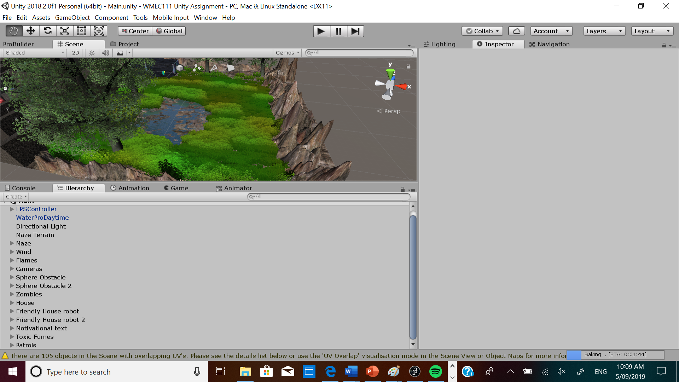

In addition, the grass was a little taskful when it came to thinning it down. Also I had to make the maze big enough for my first person controller could fit. The grass also slowed down by program a lot so I deleted it and added the grass after I finished the project.

**The zombies**

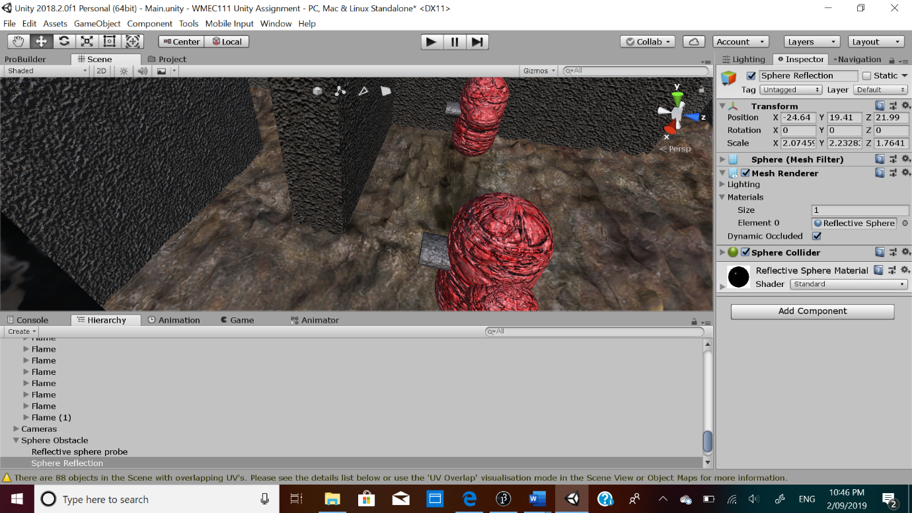

I also realised I couldn’t add the best score and time for the player and I made capsules to represent zombies as making real ones would have time consuming. I also added textures with normal maps to them.

**The Sphere Obstacle**

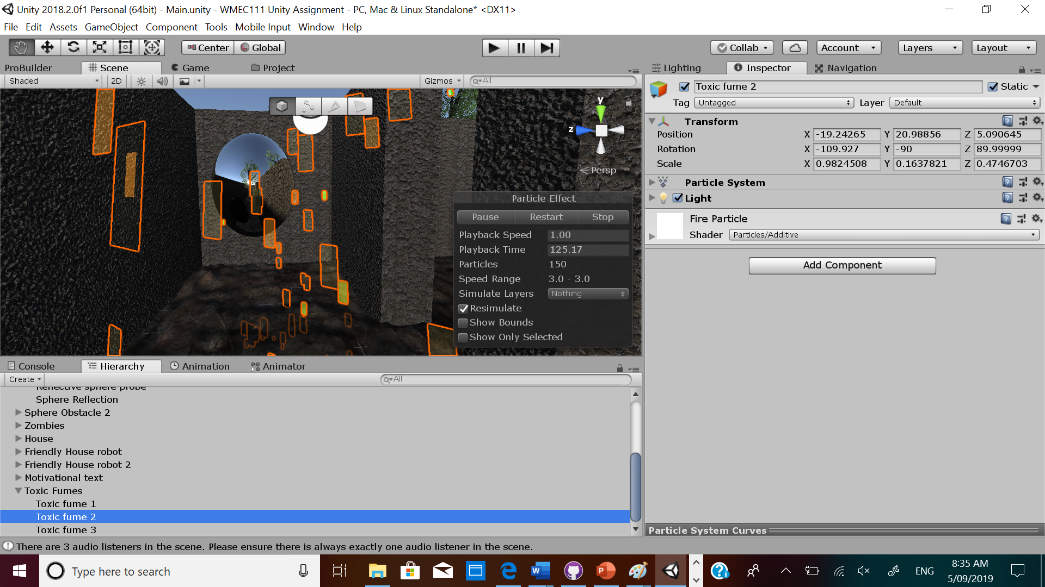

I made a toxic fume area through a particle system and a sphere obstacles with a reflective probe to add an extra challenge to the game.

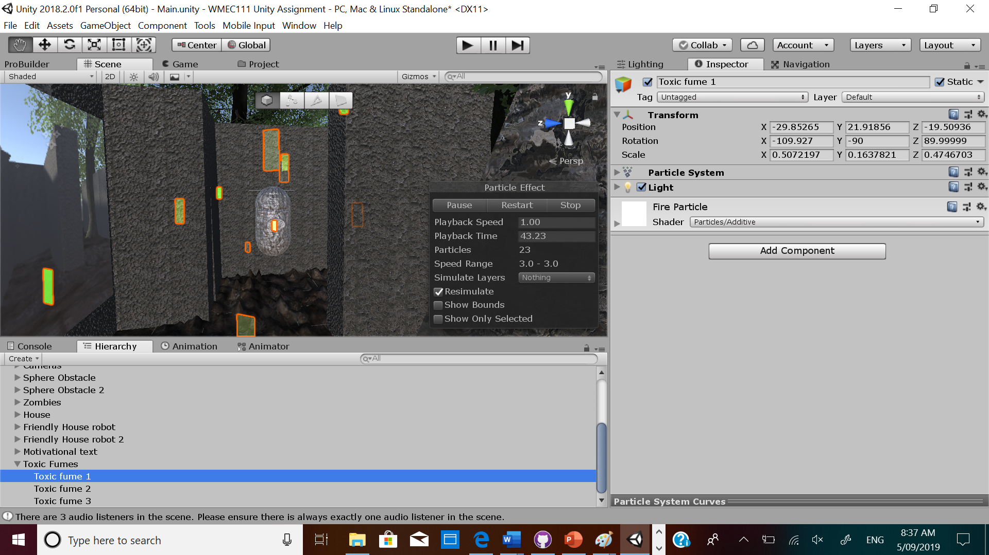

I added some patrol bodies with textures and normal maps to make the game feel more gamely. I made my zombies and patrol bodies with NavMesh agents.

**My Sun**

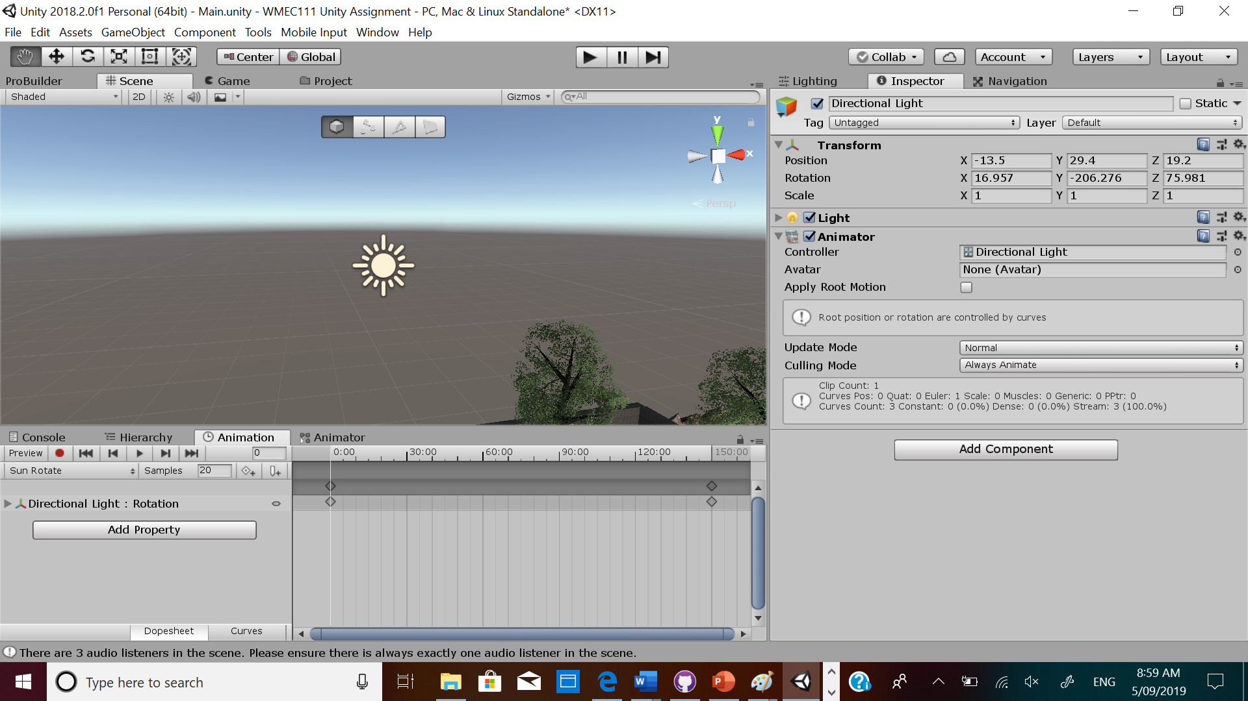

I added single-state animation to my directional light to add the elment of day and night for the duration of 5 mins.

**My House**

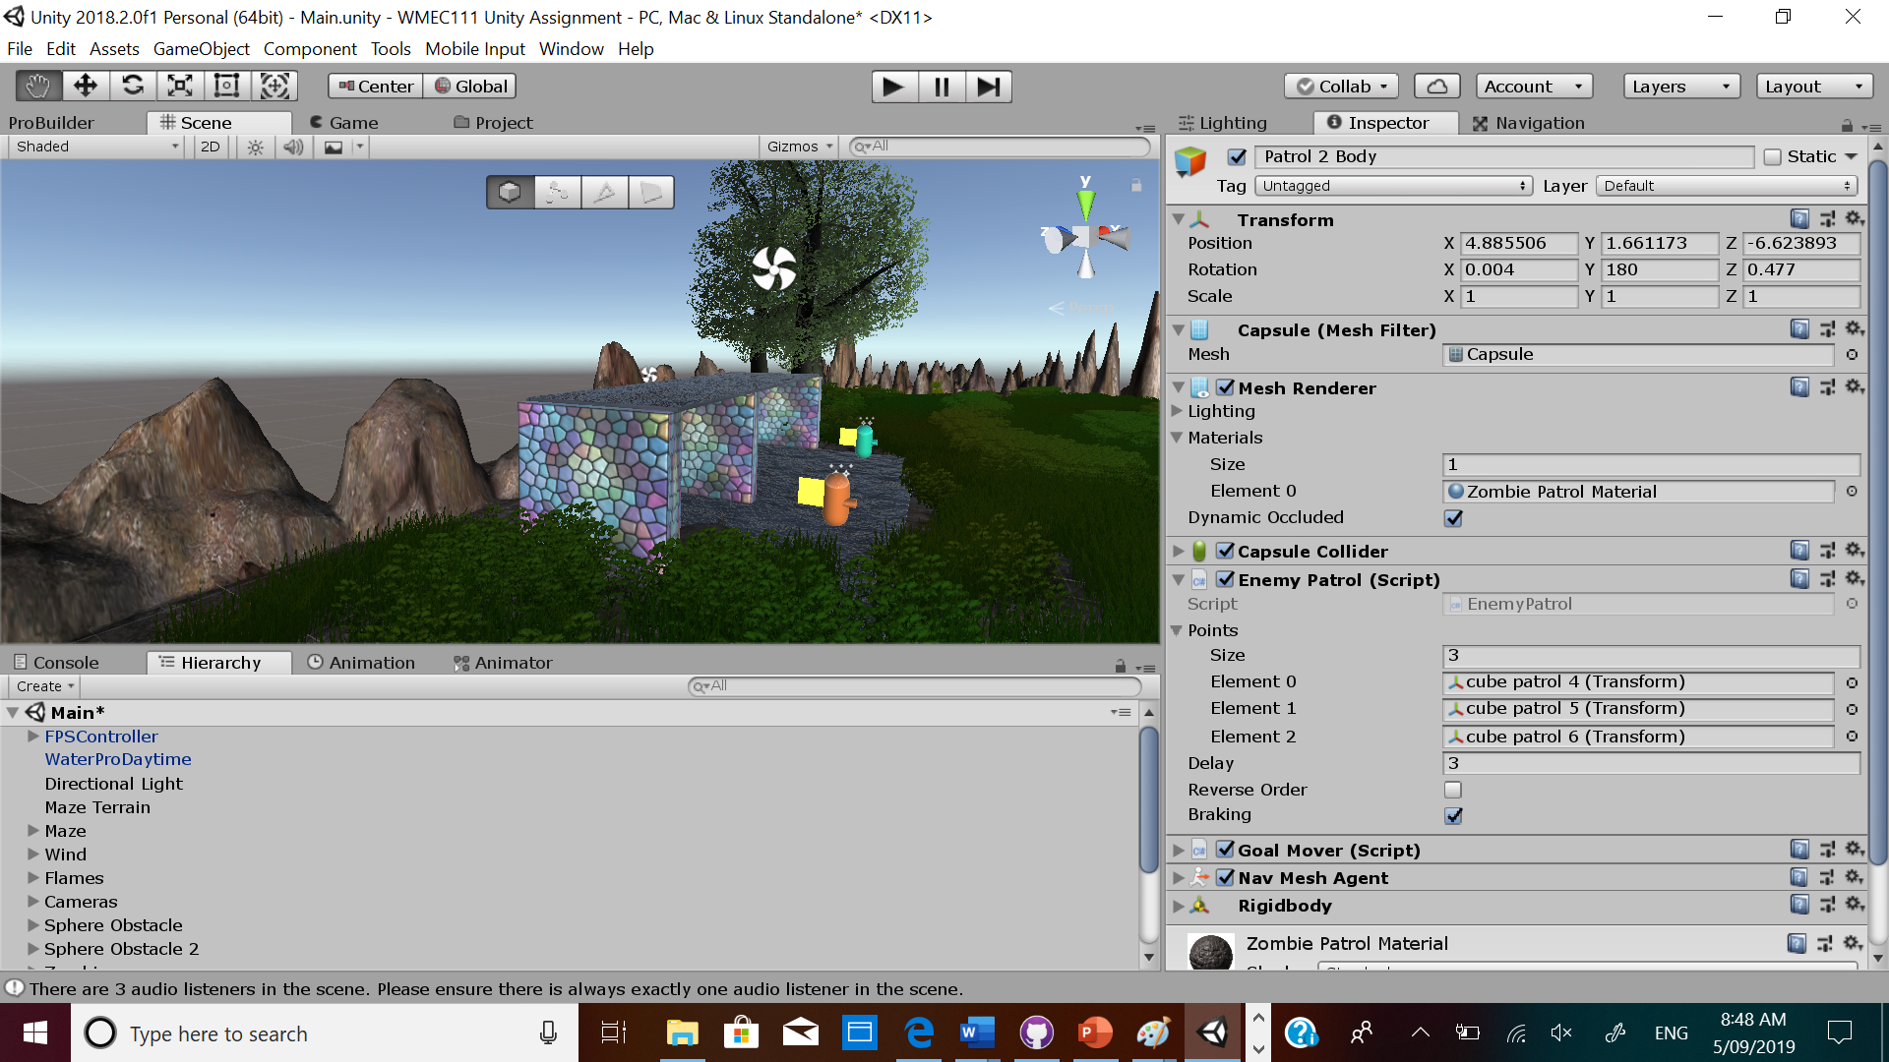

I added the element of emissive meterials attached to the friendly robots in my welcome to homeland house which also has textures and normal maps.

**Assets used**

I used trees, grass, water, wind, material and textures from the terrain of the given assets from the main teacher.

Terrain using the Terrain editor

The maze is from Unity Primitives